Life goes on in Reading during Revolution – Reading Eagle Article
2/21/2013

Q: What was Reading like during the American Revolution?
With the British in control of Philadelphia and Gen. George Washington encamped at Valley Forge, the winter of 1777-78 must have been a trying time for the people of Reading.
Nothing as mundane as a revolution, though, was going to interfere with the social season.
Indeed, if anything, the revelry in Reading was enhanced by the influx of Philadelphia socialites and Continental Army brass.
"The ensuing winter (1777-78) was gay and agreeable, notwithstanding that the enemy was in possession of the metropolis," Alexander Graydon wrote in a memoir cited in Morton L. Montgomery's "History of Berks County in the Revolution."
Graydon's papers survived because the rebel executive council had official papers removed from Philadelphia and stored in Reading, much as the Liberty Bell was stored in Zion United Church of Christ in Allentown.
Montgomery's chapter "Affairs at Reading" offers a fascinating behind-the-scenes look at social life in the city during the gravest of times for the burgeoning nation. Card parties, sleighing outings and balls were the order of the day.
There was even a cabal, or plot, to unseat George Washington as commander of the Continental Army.
After Washington's defeat in the Battle of Brandywine, some top military leaders, including then-Gen. Thomas Mifflin of Berks County, hatched the so-called Conway Cabal.
Cabal - A secret political clique or group: "a cabal of dissidents"
Gen. Thomas Conway had written letters critical of Washington to the Second Continental Congress, and the word was that he conspired with Mifflin and Gen. Horatio Gates to effect Washington's ouster.
"It began to be whispered that Gates (commander of the Northern Army) was the man who should, of right, have the station so incompetently sustained by Washington," Graydon wrote in "Memoirs of His Own Time," a reminiscence of the American Revolution. "There was, to all appearance, a cabal forming for his (Washington's) disposition."
Montgomery writes that the cabal was hatched in the Fountain Inn, near 10th and Penn streets in Reading. Later, he notes, that version was disputed.
Another version is that an offhand remark by a Gates aide-de-camp reported to Gen. William Alexander Stirling, then in command in Reading, played a role in unveiling the plot.
Whatever the intrigues, there was no rebellion against custom in that era of political discontent.
In the winter of 1781, two officers under the command of Col. Richard Butler fought a duel in Reading over a frivolous incident. One Capt. Bowen had a button shot off his uniform, but both emerged unharmed.
In September 1781, Lt. Enos Reeves wrote several letters that offer a glimpse of the social customs of the time:
"Last evening, the officers of the garrison had a ball and entertainment to which all the ladies and gentlemen of the town were invited. The ball opened at 7 o'clock with a minuet, followed by country dances. About 11 o'clock, we adjourned to a general supper. Our wines were tolerable and the music good. After supper, the dances were chiefly cotillions and concluded in a very agreeable manner about 2 o'clock in the morning."
He added: "This day has been spent very agreeably, according to custom in waiting on the ladies. I drank tea this afternoon with the agreeable Miss Nellie, her mother and sister."
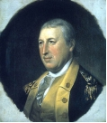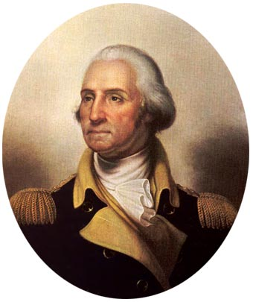
General Horatio Gates General George Washington
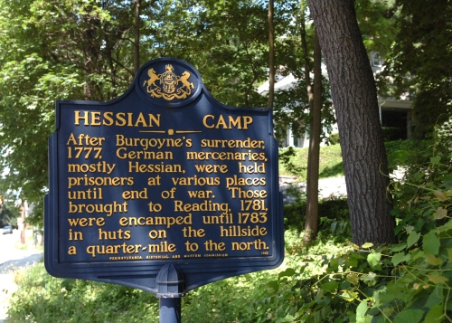
Name: _________________________________________________ Period: ___
Directions: Complete the following questions regarding the article you just read.
- How was social life in Reading during the winter of 1777-1778?

- Where was the majority of the Continental Army during the winter of 1777-1778?

- How did Graydon’s papers survive? Why did they do this?

- What author and book was used to collect much of the research for this article?

- A plot to do what has been rumored to have occurred in Reading during the Revolution?

- What happened in the winter of 1781 in Reading? Was anyone killed?

- What does Lt. Enos Reeves write about that lasts until 2 o’clock in the morning?

- The picture of the sign (which is an actual sign in the city of Reading by city park) talks about what?

- Do you think Reading played an important role in the Revolutionary War? Explain your answer in two complete sentences.

- Would a successful plot to overthrow George Washington as commander of the Continental Army be a positive or negative move in terms of the outcome of the war? Explain your answer in two complete sentences.

Total Points Earned: /12

